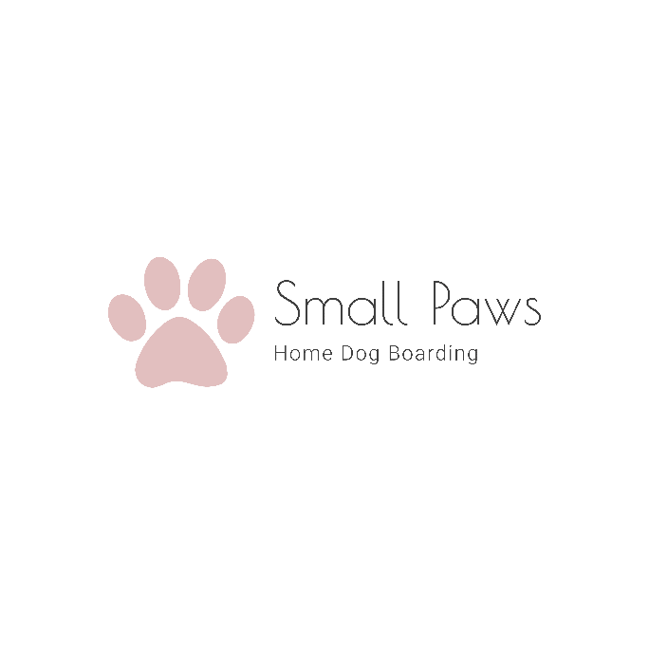
Small Paws – Home Dog Boarding
Check List
Small Paws, The Cleeve, Meriden Road, Fillongley, CV7 8DP
Telephone: Danielle, 07837532155
Email: dheavens@hotmail.co.uk
Website: www.smallpaws-homedogboarding.co.uk

Please use this checklist to make sure you are prepared for your dogs’ arrival with us. By filling in the forms and signing the terms and conditions now, will make the drop off process more time friendly and ensuring that you have checked all that you need to bring will also avoid the possibility of us having to refuse your dog.

Drop off, Collection and Viewing Times: Monday to Friday 10am to 2pm.

Please leave your dog in the car (leaving your window ajar) whilst we deal with the paper work.

1, No vaccinations, No admission. No Dog will be checked in without their up to date vaccination card and a record of the kennel cough vaccination that has been given at least two weeks prior to arrival.
2, Please bring with you the filled-out Booking Form and Register and the signed Terms and Conditions.
3, Full payment must be received on arrival by cash only.
4, Dog Food. Please remember to bring their own dog food for the duration of their stay, if we need to provide their food it is £2.50 per day, per dog.
5, Belongings. Only a small item which carries your sent is welcome.
6, Wash & Blow Dry. If you would like to have your dog washed and blow dried, please remember to add this too your payment on arrival.

